Diseases of the Rumen, Reticulum and Omasum

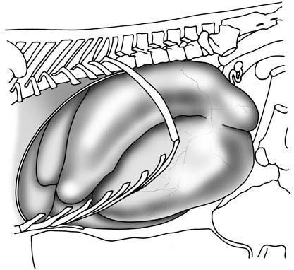
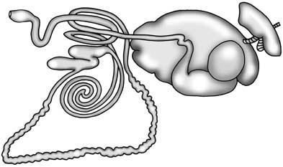

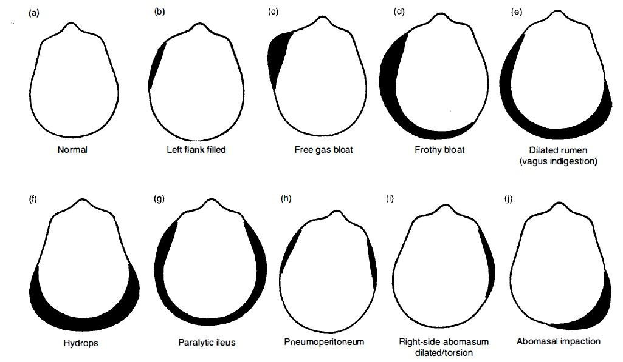

SIMPLE INDIGESTION
ETIOLOGY:
- variability in quality and the large amounts of feed consumed in dairy cattle and stall-fed beef cattle
- indigestible roughage, particularly when the protein intake is low, moldy, overheated and frosted feeds, and moderate excesses of grain and concentrate intake in pastured beef cattle or sheep.

PATHOGENESIS
- dietary abnormality
- Changes in the pH of its contents markedly affect the motility of the rumen and in cases caused by overeating on grain an increase in acidity is probably of importance.
- High protein diets, including the feeding of excessively large quantities of legumes or urea, also depress motility because of the sharp increase in alkalinity that results.
- Atony that occurs after feeding on damaged feeds may have the same basis or be due to other unidentified agents in the food.
- The simple accumulation of indigestible food may physically impede ruminal activity.
- Putrefaction of protein may also play a part in the production of atony.
- The toxic amides and amines produced may include histamine, which is known to cause ruminal atony when given in travenously and to be reversed by the administration of antihistamine drugs.
- Histamine may contribute to the ruminal atony that occurs in allergy, or after heavy grain feeding, but the absorption of histamine from the forestomachs in any circumstances is probably very limited.
CLINICAL FINDINGS:
- A reduction in appetite is the first clinical finding,
- followed closely in milking cows by a slight drop in milk production. Both occur suddenly;
- the anorexia may be partial or complete but the fall in milk yield is relatively slight.

- The animal's posture is unaffected but there is mild depression and dullness.
- Rumination ceases and the ruminal movements are depressed in frequency and amplitude and sometimes are almost absent
- The rumen may be larger than normal if the cause is sudden access to an unlimited supply of palatable feed.
- There may be moderate tympany, especially with frozen or damaged feeds or in allergy, but the usual finding is a firm, doughy rumen without obvious distension.
- The feces are usually reduced in quantity and are drier than normal on the first day.
- However, 24-48 hours later the animal is commonly diarrheic; the feces are softer than normal, voluminous and commonly malodorous.
- There is no systemic reaction and the heart rate, temperature and respirations are usually within normal ranges 11- Most cases recover spontaneously or with simple
treatments in about 48 hours.
CLINICAL PATHOLOGY
- Two simple laboratory tests have been introduced to assess the activity of the ruminal microflora
a- The sediment activity test b- The cellulose digestion test
- The rumen juice can be examined for pH using wide-range indicator paper.
- Values between 6.5 and 7.0 are considered normal. In cattle on grain diets, the pH may range from 5.5-6.0 normally but in cattle that have been on roughage diets.
DIFFERENTIAL DIAGNOSIS:

Medicine Lecture 4th Year 2017 Dr.Alaa kamil

- Acetonemia
- Traumatic reticuloperitonitis
- Carbohydrate engorgement
- Left-side displacement of the abomasum (LDA) 5- Right-side dilatation of abomasum
- Abomasal volvulus
- Vagal indigestion
- Phytobezoars
- Secondary ruminal atony TREATMENT
- Spontaneous recovery
- Small quantities of fresh, good-quality, palatable hay should be provided several times daily to encourage eating and to stimulate reticulorumen motility
- Rumenatorics : These preparations contained nux vomica, ginger and tartar emetic in powder form to be added to water and pumped into the rumen
- Alkalinizing and acidifying agents: magnesium hydroxide, at the rate of 400 g per adult cow (450 kg BW), is recommended when the rumen contents are excessively acid.
- Reconstitution of ruminal microflora: An abattoir is the best source of rumen contents (especially rumen fluid)
- rumen lavage

